Lab 3 Report
The purpose of this lab is to solidify you to the usage of some important lab equipments. This lab will allow you to learn about short circuits, voltage source, a breadboard, a multimeter.

Component List
- 5 x 1kOhm Resistor
- 2 x 10kOhm Resistor
- 1 x 4.7kOhm Resistor
- 1 x 2.2kOhm Resistor
- 1 x 1.5kOhm Resistor

Useful Equations

Experiment 1
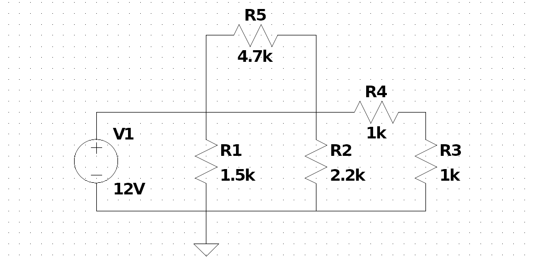Figure 1: Circuit diagram of Experiment 1.

Components and Instruments used:
- A computer: used in the pre-lab to get experiment details from the Moodle
- Resistor kit: contains the resistors to create circuits in the breadboard
- Tektronix PS280 power supply: voltage source
- Fluke multimeter: used to get measurements such as potential difference, current, etc.
- Breadboard: used to create circuits and connect wires to find values

Procedure:
- Create the circuit shown in Figure 1 on breadboard using the shown resistor values.
- Connect the power supply and set it to the 12V of DC voltage.
- Set the multimeter to voltage measurement mode and for each resistor, connect the multimeter as parallel to the resistors and measure the voltage drops.
- Set the multimeter to current measurement mode and for each resistor, connect the multimeter as series before or after to the resistor that you want to measure the current passing through.

Results
RESULTS WITHOUT UNITS WILL NOT BE GRADED!
Table 1: Voltage measurements.
VARIABLE | CALCULATED | MEASURED | ERROR%
V_{R1} |  | 12V
V_{R2} |  | 12V
V_{R3} |  | 6V
V_{R4} |  | 6V
V_{R5} |  | 0V

Table 2: Current measurements.
VARIABLE | CALCULATED | MEASURED | ERROR%
I_{R1} |  | 8mA
I_{R2} |  | 5.45mA
I_{R3} |  | 6mA
I_{R4} |  | 6mA
I_{R5} |  | 0mA

Experiment 2 – Voltage Divider
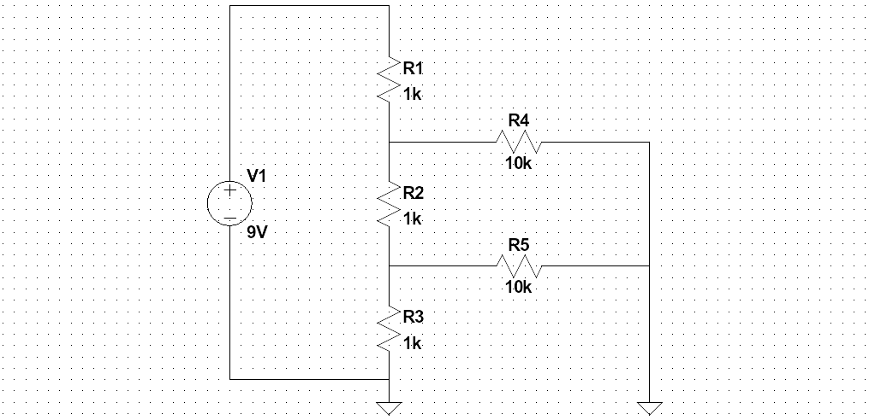Figure 2: Circuit diagram of Experiment 2.

Components and Instruments used:
- A computer: used in the pre-lab to get experiment details from the Moodle
- Resistor kit: contains the resistors to create circuits in the breadboard
- Tektronix PS280 power supply: current source
- Fluke multimeter: used to get measurements such as potential difference, current, etc.
- Breadboard: used to create circuits and connect wires to find values

Procedure:
- Create the circuit shown in Figure 2 on breadboard using the shown resistor values.
- Connect the power supply in constant voltage mode and set the voltage to 9V.
- Set the multimeter to voltage measurement mode and for each resistor, connect the multimeter as parallel to the resistors and measure the voltage drops.
- Set the multimeter to current measurement mode and for each resistor, connect the multimeter as series before or after to the resistor that you want to measure the current passing through.
- Compare the resistor ratios R1, R2, and R3 to potential difference over load R4 and R5. Verify that the potential difference over R3 and 9V is proportional to the R2 and R1.

Results
RESULTS WITHOUT UNITS WILL NOT BE GRADED!
Table 3: Voltage measurements.
VARIABLE | CALCULATED | MEASURED | ERROR%
V_{R1} |  | 3.46V
V_{R2} |  | 2.90V
V_{R3} |  | 2.64V
V_{R4} |  | 5.54V
V_{R5} |  | 2.64V
Table 4: Current measurements.
VARIABLE | CALCULATED | MEASURED | ERROR%
I_{R1} |  | 3.45mA
I_{R2} |  | 2.9mA
I_{R3} |  | 2.62mA
I_{R4} |  | 0.57mA
I_{R5} |  | 0.23mA

Table 5: Voltage dividing results for R4.
RATIO | THEORIC V_{R4} W/O LOAD | MEASURED V_{R4} W/ LOAD | ERROR%
 | 6.0003V | 5.54V | 7.67%
Table 6: Voltage dividing results for R5.
RATIO | THEORIC V_{R5} W/O LOAD | MEASURED V_{R5} W/ LOAD | ERROR%
 | 2.9997 | 2.64V | 11.99%

